Defining Objects

Object Literal Syntax:

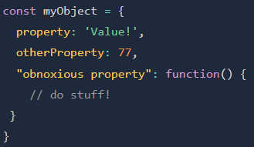

Accessing Values in an Object

Dot Notation:

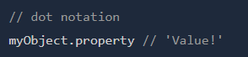

* Cleaner

Bracket Notation:

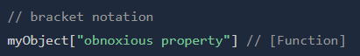

* Properties can be: (which dot notation can’t)
  + Variables
  + Strings with spaces